Method overloading->

If a class has multiple methods having same name but different in parameters, it is known as **Method Overloading**.

Different ways to overload the method->

There are two ways to overload the method in java

1. By changing number of arguments.
2. By changing the data type.

**\*\*\*In java, Method Overloading is not possible by changing the return type of the method only.**

1.by changing number of argument->

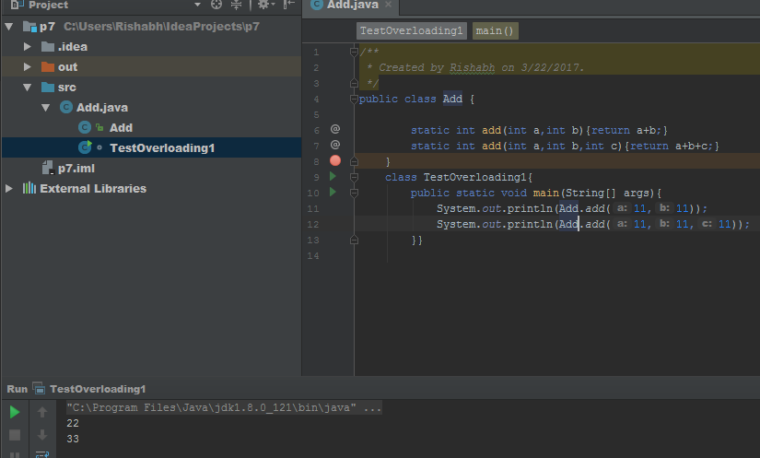

2.By changing type of method->

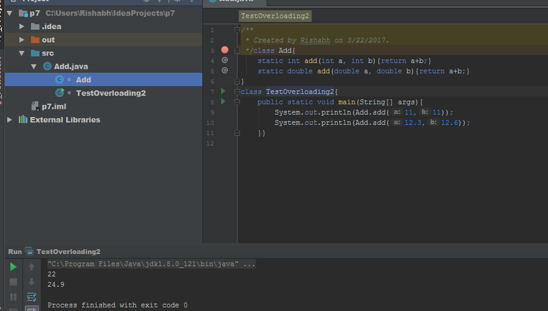

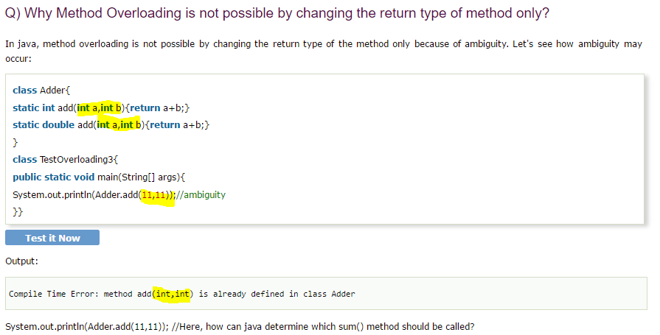

Q.can we overload the main method yes->

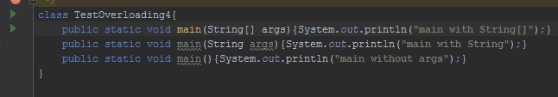

Method overriding in Java->

 subclass (child class) has the same method as declared in the parent class, it is known as **method overriding in java**.

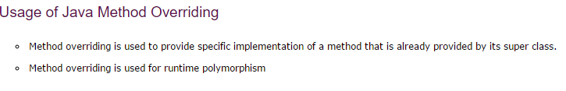

Rules for Java Method Overriding

1. method must have same name as in the parent class
2. method must have same parameter as in the parent class.
3. must be IS-A relationship (inheritance).

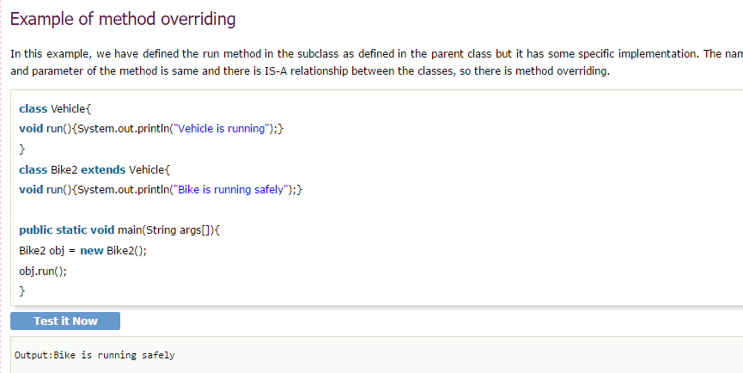

Real example->

